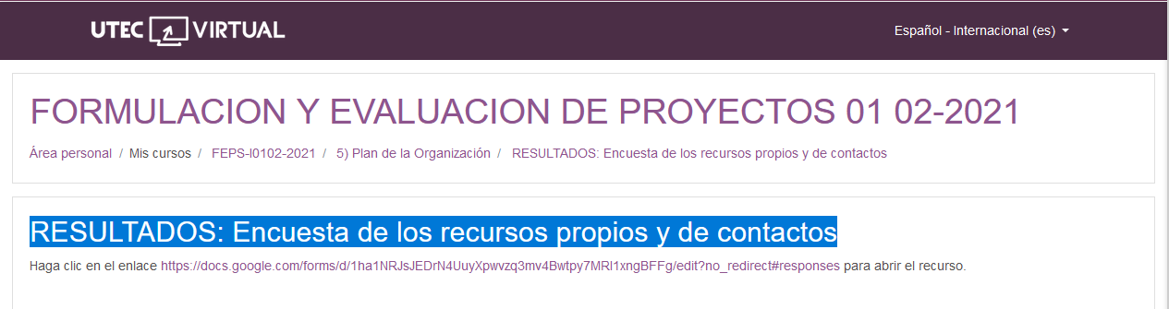

<https://docs.google.com/forms/d/1ha1NRJsJEDrN4UuyXpwvzq3mv4Bwtpy7MRI1xngBFFg/edit?no_redirect#responses>